- Convert any classroom or community site into a simulated work environment.  - Individuals become employees.  - Educators become employers.  - Educators can assess a student's competitive work potential and interest level  - Individuals will career explore in various jobs, using real tools, while developing appropriate work behaviors in the following five areas: |  |  |  |  |  |  |  | “We will never really know what each individual can do, until we give them a chance to try”  Dr. Judith Swisher, PAES Author

Valerie Kean

Illinois Sales Executive &

Certified Trainer

309.231.7470 or Valerie@talentassessment.com

 |  |  | IDENTIFYING CAPABILITIES:  TAP – Talent Assessment Program  Individuals are given 10 Hands-On tests that measure functional vocational aptitudes, we make it easy to assess your individual’s capabilities. TAP is a Formal Normed based assessment that can be used with all individuals – no reading is required, so TAP can be group administered, and is easily transportable.  IDENTIFYING INTERESTS:  PIC - Pictorial Inventory of Careers  PIC helps assess an individual’s interests in specific work fields. PIC will show a variety of 8-10 second work scenes while capturing the indivudual’s response. This assessment will link the individual’s chosen interest to the 17 Department of Labor’s 17 career pathways. This assessment can be administered directly through the WayPoint SCP system, keeping it convenient, portable, and easily accessible. |  |  | Valerie Kean Illinois Sales Executive & Certified Trainer  309.231.7470  Valerie@Talentassessment.com
WayPoint SCP is a comprehensive Transition Planning System that identifies any individuals’ abilities, interests, & suitability with real job opportunities. These are then brought together in a real-time summary report to easily view, track, and report for transitional progress.  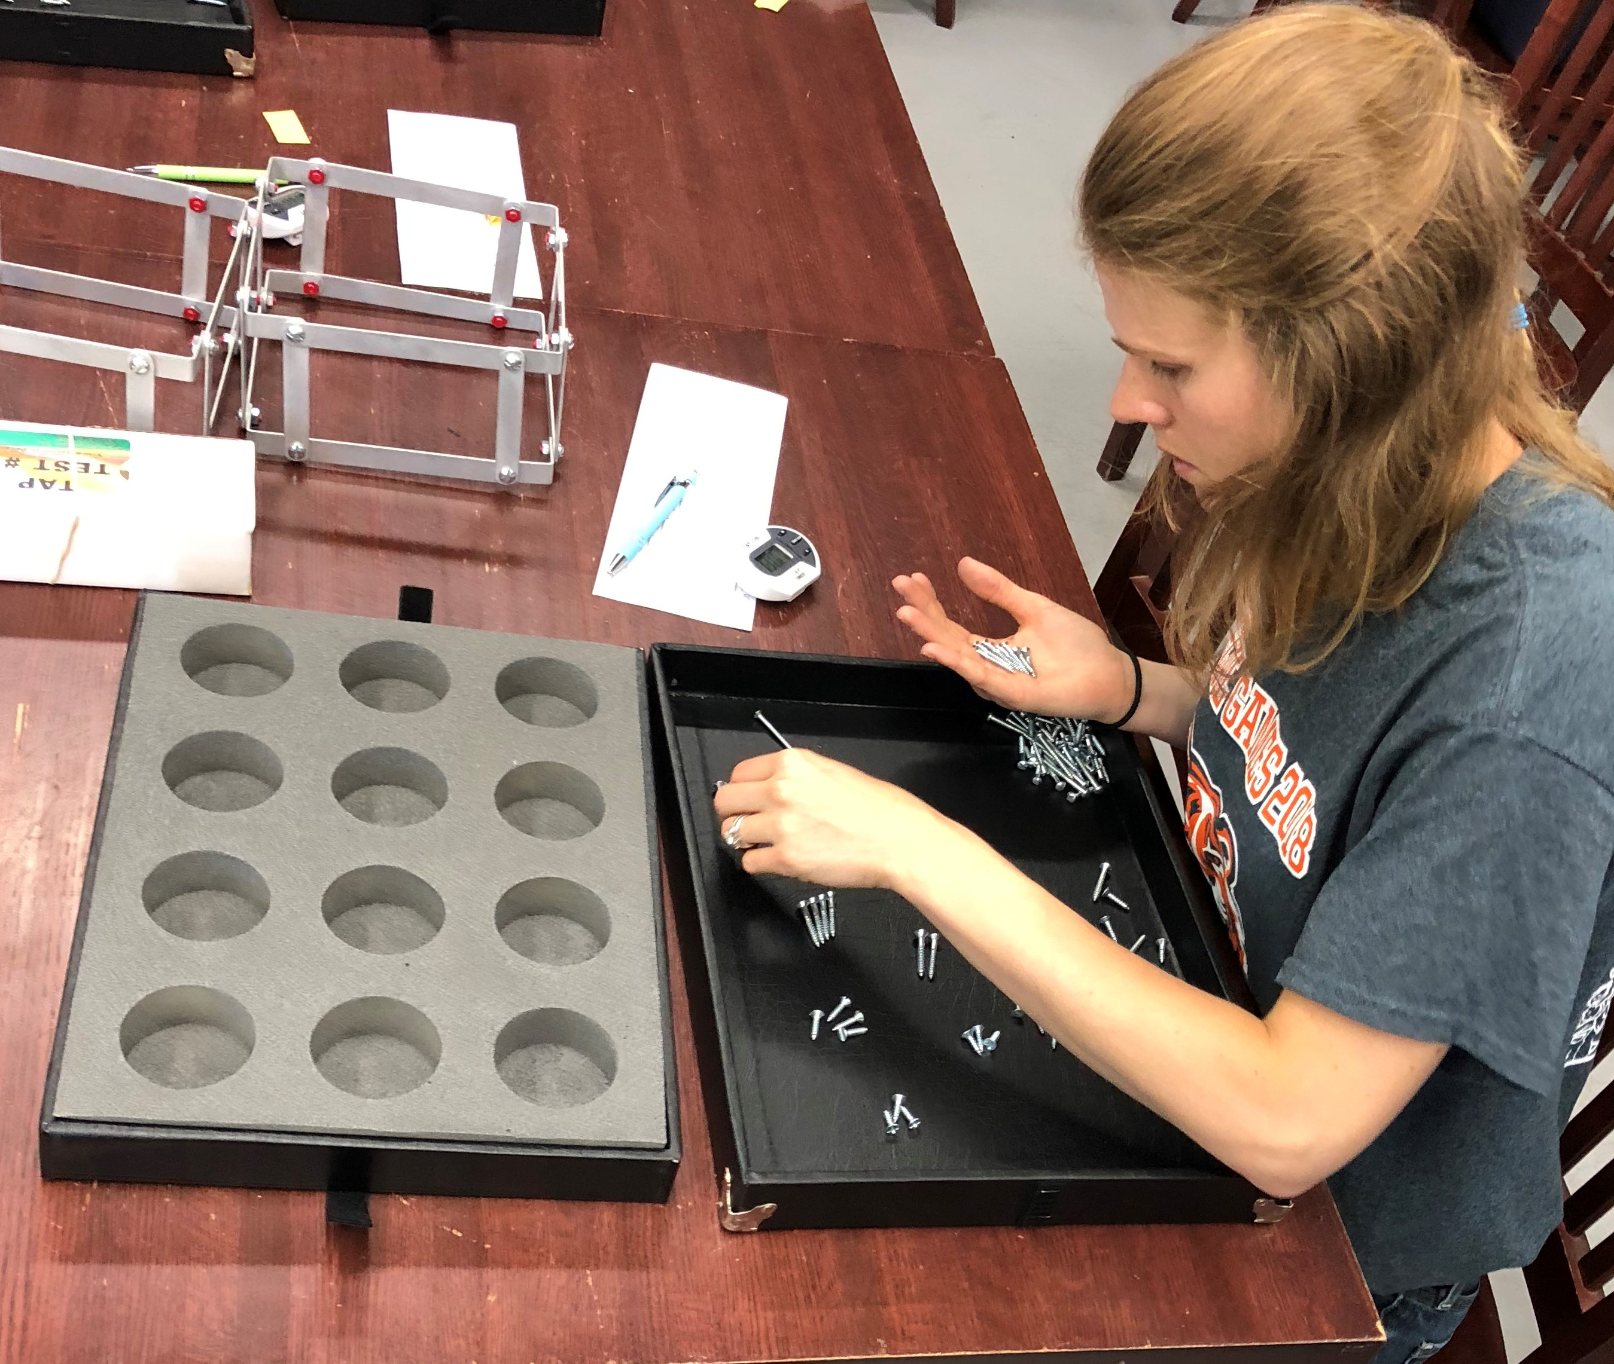 |  |  |  |  |  | Filling the Gap in Transition Planning  Is the progress of your transitioning individual being adequately monitored from school to work & independent living? With WayPoint SCP you can provide:  - Assessments & meaningful results of real job opportunities available.  - Links to employers in each individual’s own community.  - A real plan for each individual’s academic career directed toward career.  - A real plan for transitioning from school to work.  - Comprehensive data organization of necessary documentation on every individual.  - Instant reports for planning and progress monitoring.  *TAP, PIC, & VIP can all be sold individually outside of the WayPoint SCP package.
IDENTIFYING SUITABILITY:
VIP - Vocational Implications of Personality
Identify an individual’s distinct personality type and begin to determine the best career path to follow. VIP has options for non-reading individuals as well as Spanish speaking individuals.

